Algebra 3-4 Name: ______________________
Quiz Block: _____

Factor the expression completely.

1. m² – 9m + 20 2. 4u² – 4u – 35 3. 25n² – 49

4. 16m² – 24m – 9 5. 7y³ + 2y² – 6y 6. 15x² – 6x – 21

Simplify the expression.

7. 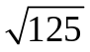 8. 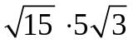 9. 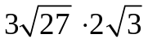

10. 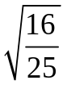 11. 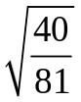 12. 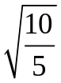

Find the value of x.

13. Area = 15 in²

x in

(20 – 5x) in

Solve the equation.

14. x² + 10x + 21 = 0 15. 3x² – 24x – 27 = 0

16. x² – 8x = -15 17. 8k² + 5k = 2k² + 4

18. 9r² + 30r + 25 = 0 19. 16y² – 80y = 0

20. x² = 289 21. 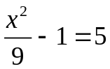

22. 